Polytechnic University of Puerto Rico

Department of Electrical Engineering

Hato Rey

Module 8 Project COE 4331

Computer Networks Laboratory

January 4, 2025

Schmidt Montilla, Coral S., Student ID: 148830

Professor: Juan Tovar

Table of Contents

Introduction 3

Method 4

Objectives 4

Background 4

Instructions 4

Gather PDU Information for Local Network Communication 4

Gather additional PDU information from other pings. 4

Gather PDU Information for Remote Network Communication 5

Gather PDU information as a packet travels from 172.16.31.5 to 10.10.10.2. 5

Reflection Questions 5

Lab Results 8

Conclusion 9

References 10

# Introduction

This assignment investigates essential concepts and protocols associated with wireless networking and their practical applications. By addressing a series of questions, we examine the roles and functions of various wireless technologies, including 802.11, Bluetooth, and 802.15.1 PAN, along with their foundational mechanisms such as MAC addressing, RTS thresholds, and beacon frames. Through this analysis, the assignment highlights the importance of comprehending protocol design and tackling challenges in network operation and configuration.

# Method

Packet Tracer - Identify MAC and IP Addresses

# Objectives

Part 1: Gather PDU Information for Local Network Communication

Part 2: Gather PDU Information for Remote Network Communication

# Background

This activity is optimized for viewing PDUs. The devices are already configured. You will gather PDU information in simulation mode and answer a series of questions about the data you collect.

# Instructions

## Gather PDU Information for Local Network Communication

**Note**: Review the Reflection Questions in Part 3 before proceeding with Part 1. It will give you an idea of the type of information you will need to gather PDU information as a packet travels from 172.16.31.5 to 172.16.31.2.

* + - 1. Click **172.16.31.5** and open the **Command Prompt**.
      2. Enter the **ping 172.16.31.2** command.
      3. Switch to simulation mode and repeat the **ping 172.16.31.2** command. A PDU appears next to **172.16.31.5**.
      4. Click the PDU and note the following information from the **OSI Model** and **Outbound PDU Layer** tabs:
* Destination MAC Address: **000C:85CC:1DA7**
* Source MAC Address: **00D0:D311:C788**
* Source IP Address: **172.16.31.5**
* Destination IP Address: **172.16.31.2**
* At Device: **172.16.31.5**
  + - 1. Click **Capture / Forward (the right arrow followed by a vertical bar)** to move the PDU to the next device. Gather the same information from Step 1d. Repeat this process until the PDU reaches its destination. Record the PDU information you gathered into a spreadsheet using a format like the table shown below:

Example Spreadsheet Format

| At Device | Dest. MAC | Src MAC | Src IPv4 | Dest IPv4 |
| --- | --- | --- | --- | --- |
| 172.16.31.5 | 000C:85CC:1DA7 | 00D0:D311:C788 | 172.16.31.5 | 172.16.31.2 |
| Switch1 | 000C:85CC:1DA7 | 00D0:D311:C788 | N/A | N/A |
| Hub | N/A | N/A | N/A | N/A |
| 172.16.31.2 | 00D0:D311:C788 | 000C:85CC:1DA7 | 172.16.31.2 | 172.16.31.5 |

### Gather additional PDU information from other pings.

Repeat the process in Step 1 and gather the information for the following tests:

* Ping 172.16.31.2 from 172.16.31.3.
* Ping 172.16.31.4 from 172.16.31.5.

Return to Realtime mode.

## Gather PDU Information for Remote Network Communication

In order to communicate with remote networks, a gateway device is necessary. Study the process that takes place to communicate with devices on the remote network. Pay close attention to the MAC addresses used.

### Gather PDU information as a packet travels from 172.16.31.5 to 10.10.10.2.

* + - 1. Click **172.16.31.5** and open the **Command Prompt**.
      2. Enter the **ping 10.10.10.2** command.
      3. Switch to simulation mode and repeat the **ping 10.10.10.2** command. A PDU appears next to **172.16.31.5**.
      4. Click the PDU and note the following information from the **Outbound PDU Layer** tab:
* Destination MAC Address: 00D0:BA8E:741A
* Source MAC Address: 00D0:D311:C788
* Source IP Address: 172.16.31.5
* Destination IP Address: 10.10.10.2
* At Device: 172.16.31.5

#### Question:

What device has the destination MAC that is shown?

Type your answers here.

* + - 1. Click **Capture / Forward (the right arrow followed by a vertical bar)** to move the PDU to the next device. Gather the same information from Step 1d. Repeat this process until the PDU reaches its destination. Record the PDU information you gathered from pinging 172.16.31.5 to 10.10.10.2 into a spreadsheet using a format like the sample table shown below:

| At Device | Dest. MAC | Src MAC | Src IPv4 | Dest IPv4 |
| --- | --- | --- | --- | --- |
| 172.16.31.5 | 00D0:BA8E:741A | 00D0:D311:C788 | 172.16.31.5 | 10.10.10.2 |
| Switch1 | 00D0:BA8E:741A | 00D0:D311:C788 | N/A | N/A |
| Router | 0060:2F84:4AB6 | 00D0:588C:2401 | 172.16.31.5 | 10.10.10.2 |
| Switch0 | 0060:2F84:4AB6 | 00D0:588C:2401 | N/A | N/A |
| Access Point | N/A | N/A | N/A | N/A |
| 10.10.10.2 | 00D0:588C:2401 | 0060:2F84:4AB6 | 10.10.10.2 | 172.16.31.5 |

## Reflection Questions

Answer the following questions regarding the captured data:

* 1. Were there different types of cables/media used to connect devices?

Yes, there were copper, fiber, and wireless media used.

* 1. Did the cables change the handling of the PDU in any way?

No, layer one and layer two protocols remain independent, and the Ethernet frame stayed the same.

* 1. Did the **Hub** lose any of the information that it received?

No, the Hub cloned the signal and sent it out all ports.

* 1. What does the **Hub** do with MAC addresses and IP addresses?

The Hub does not process MAC or IP addresses; it simply forwards signals.

* 1. Did the wireless **Access Point** do anything with the information given to it?

Yes, it repackaged the Ethernet frame into an 802.11 wireless frame.

* 1. Was any MAC or IP address lost during the wireless transfer?

No, the MAC and IP addresses were preserved during the transfer.

* 1. What was the highest OSI layer that the **Hub** and **Access Point** used?

The Hub used Layer 1, while the Access Point used Layer 2.

* 1. Did the **Hub** or **Access Point** ever replicate a PDU that was rejected with a red “X”?

Yes, the Access Point replicated rejected PDUs during the return trip.

* 1. When examining the **PDU Details** tab, which MAC address appeared first, the source or the destination?

The destination MAC address appeared first in the PDU Details tab.

* 1. Why would the MAC addresses appear in this order?

The destination MAC address appears first because switches can begin forwarding frames more quickly if they know the destination address first.

* 1. Was there a pattern to the MAC addressing in the simulation?

No, there was no discernible pattern to the MAC addressing in the simulation.

* 1. Did the switches ever replicate a PDU that was rejected with a red “X”?

No, switches did not replicate a PDU that was rejected. Only hubs or access points replicated PDUs, as seen in the simulation.

* 1. Every time that the PDU was sent between the 10 network and the 172 network, there was a point where the MAC addresses suddenly changed. Where did that occur?

The MAC addresses changed at the router because the router processes the packet and assigns a new MAC address for the next hop.

* 1. Which device uses MAC addresses that start with 00D0:BA?

The router uses MAC addresses that start with 00D0:BA.

* 1. What devices did the other MAC addresses belong to?

The other MAC addresses belonged to the PCs, switches, and access points in the simulation.

* 1. Did the sending and receiving IPv4 addresses change fields in any of the PDUs?

No, the sending and receiving IPv4 addresses remained the same throughout the PDUs.

* 1. When you follow the reply to a ping, sometimes called a *pong*, do you see the sending and receiving IPv4 addresses switch?

Yes, during a reply to a ping, the sending and receiving IPv4 addresses switch places.

* 1. What is the pattern to the IPv4 addressing used in this simulation?

Each port of a router requires a unique and non-overlapping IPv4 address range, ensuring proper routing between networks.

* 1. Why do different IP networks need to be assigned to different ports of a router?

Different IP networks are assigned to different router ports to enable interconnection and routing between distinct address ranges.

* 1. If this simulation was configured with IPv6 instead of IPv4, what would be different?

The IPv4 addresses would be replaced by IPv6 addresses, but the layer 1 and layer 2 information would remain the same. Additionally, IPv6 includes extended addressing and simplified routing.

# Lab Results

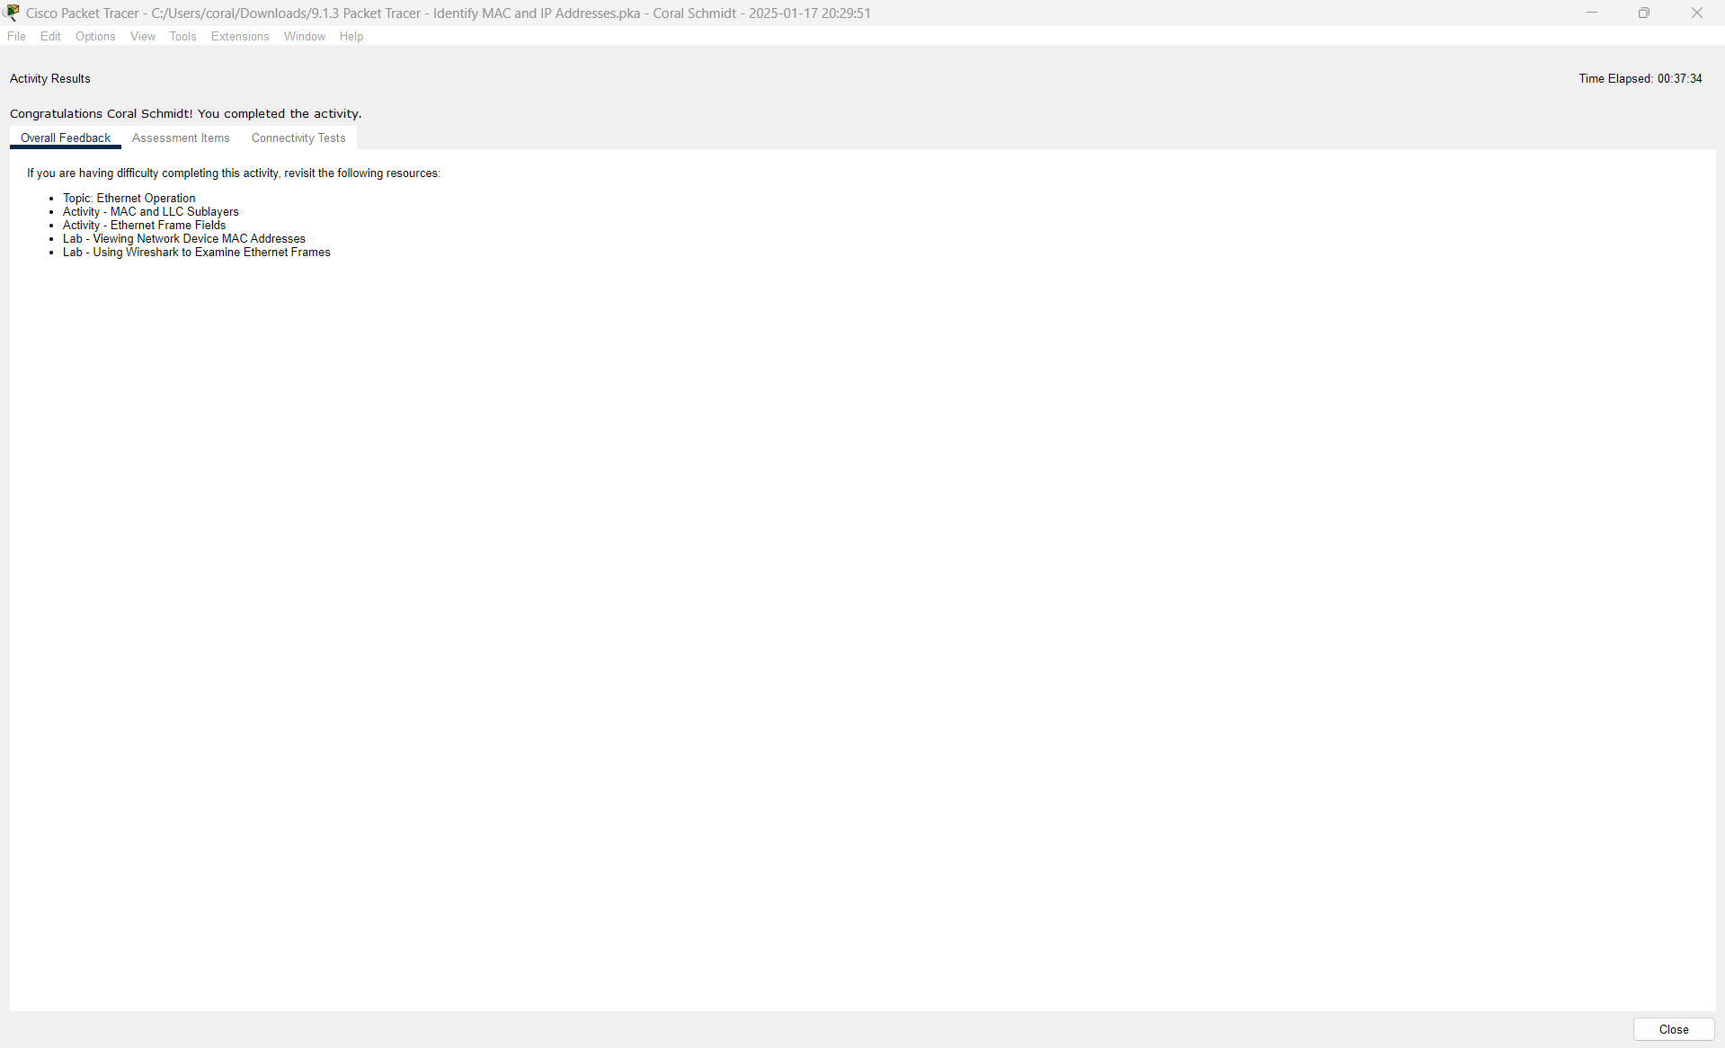

# Conclusion

This document delves into the critical elements of wireless networking and their real-world applications. By exploring the characteristics, constraints, and differences among various protocols, we enhance our comprehension of their design principles and how they tackle specific network issues. This assignment emphasizes the significance of understanding fundamental concepts in computer networking to proficiently diagnose and improve wireless communication systems across various contexts.

# References

‌ [1] *Youtube.com*, 2024. Available: https://www.youtube.com/watch?v=y32CYvtXg4o. [Accessed: Jan. 18, 2025]‌

[2] *Youtube.com*, 2024. Available: https://www.youtube.com/watch?v=5iS2U9us7Ac. [Accessed: Jan. 18, 2025]

‌

‌

‌

‌